Lab 5
Natnael Kebede
Section 1
- Screen capture showing Natnael_tftp.txt (the file I created) in the Tftpd64 directory
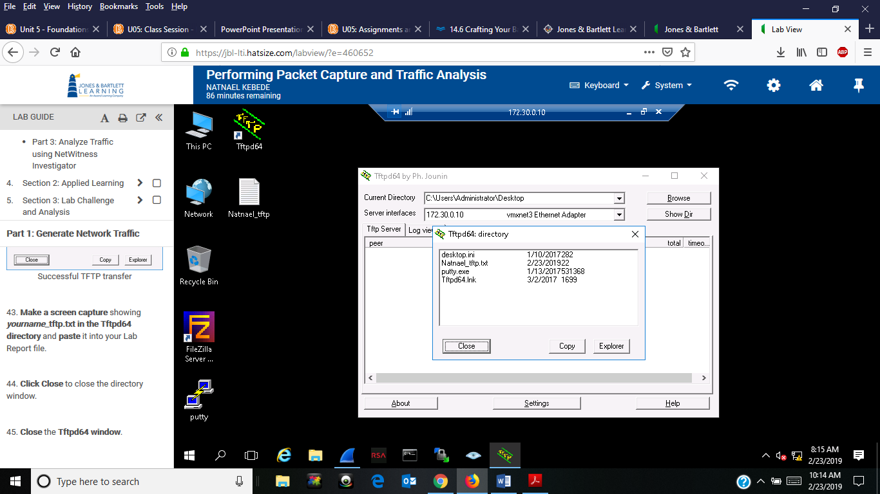

- Screen capture showing successful file transfer using FileZilla
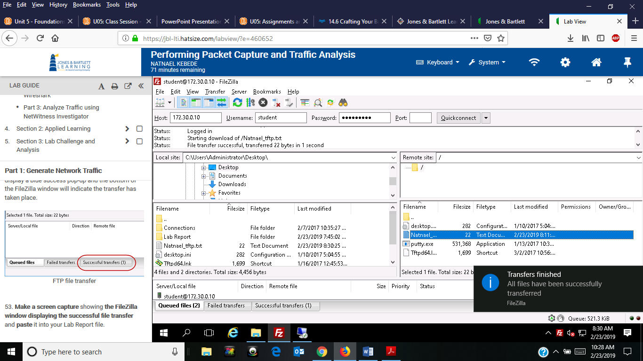
- Screen capture showing the captured file transfer in the entire Wireshark window
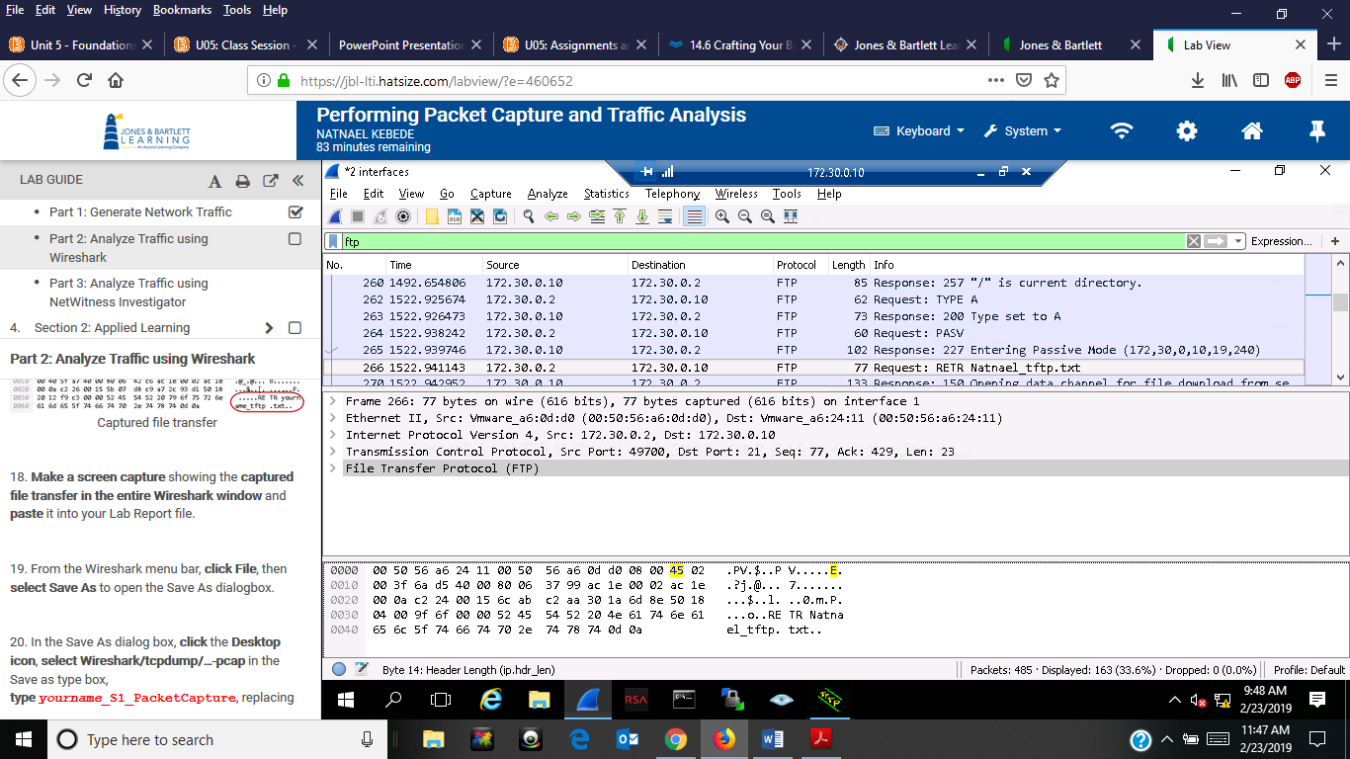

- Screen capture showing the password information for Natnael_Collection
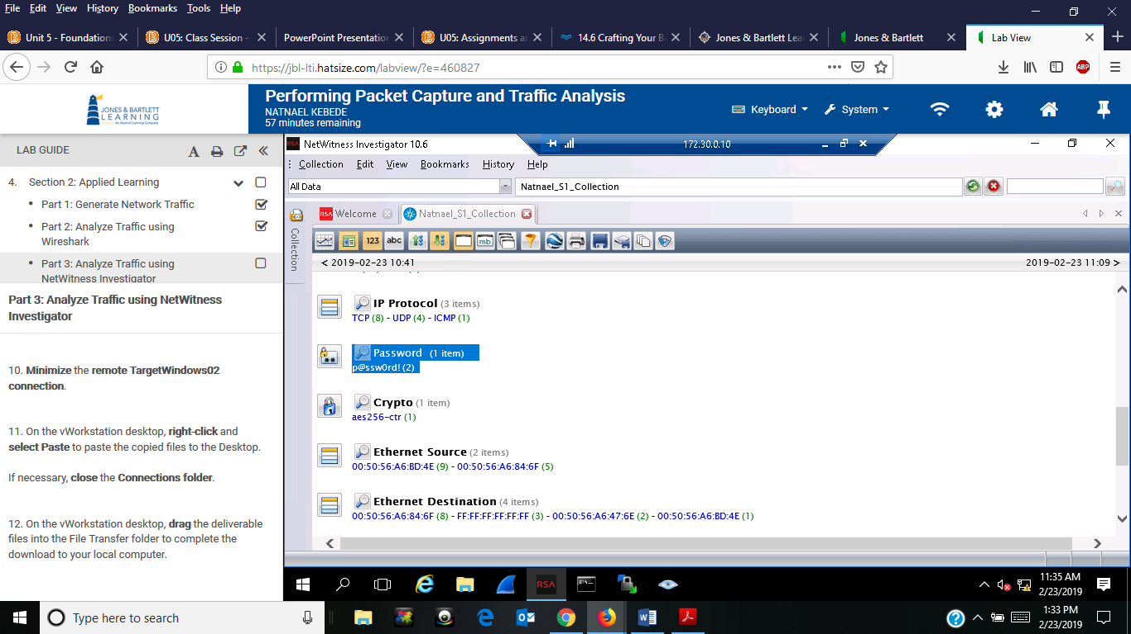
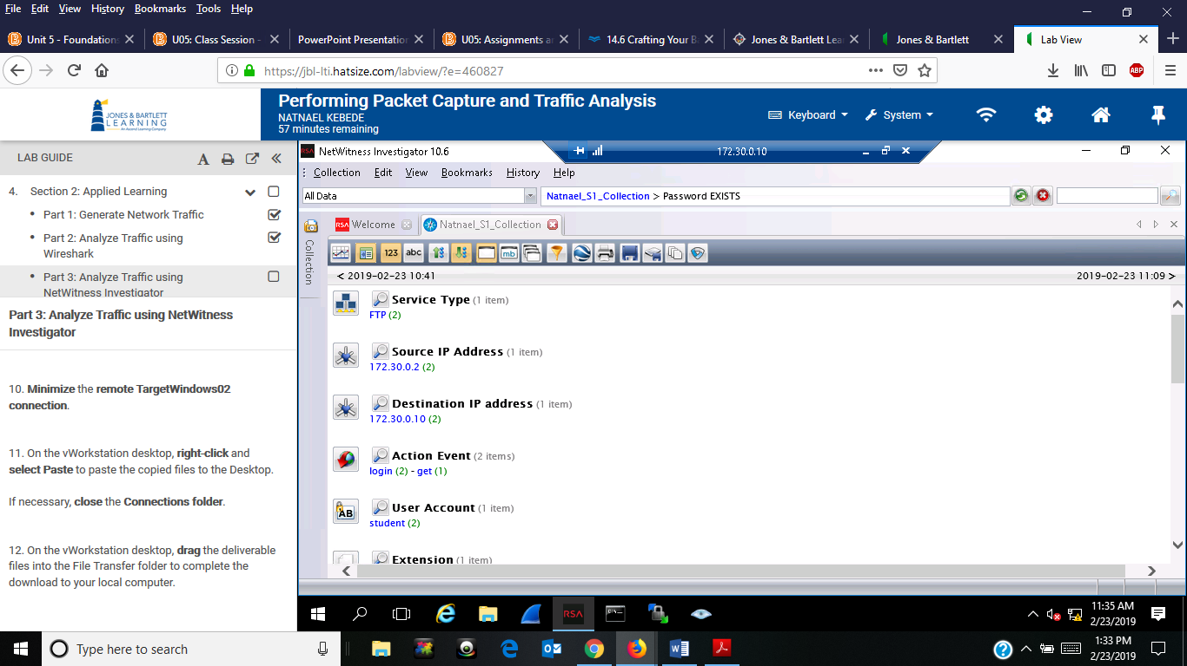

Section 2
1) Screen capture showing Natnael_S2_tftp.txt (the file I created) in the Tftpd64 directory
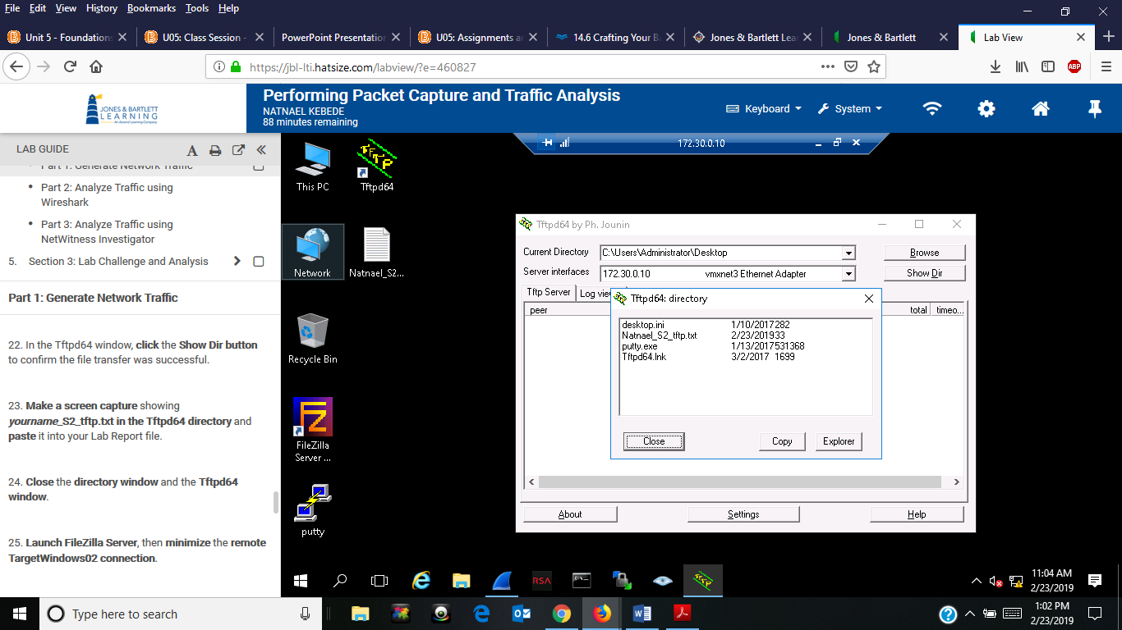

2) Screen capture showing successful file transfer using FileZilla
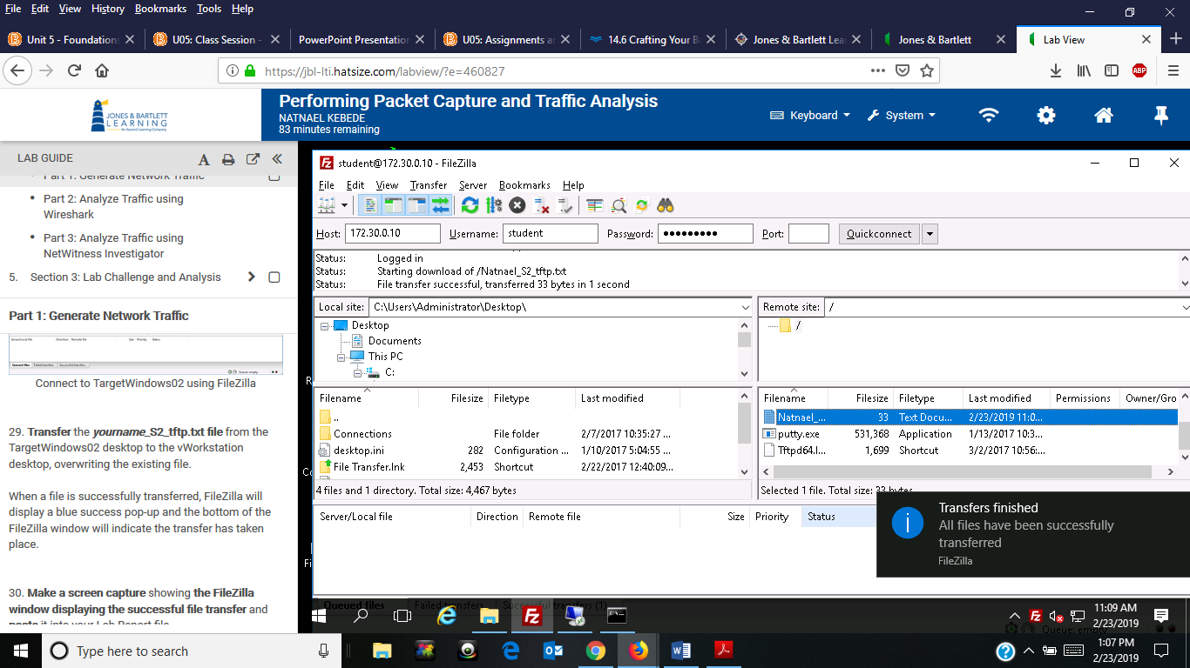

3) Screen capture showing the captured file transfer in the entire Wireshark window
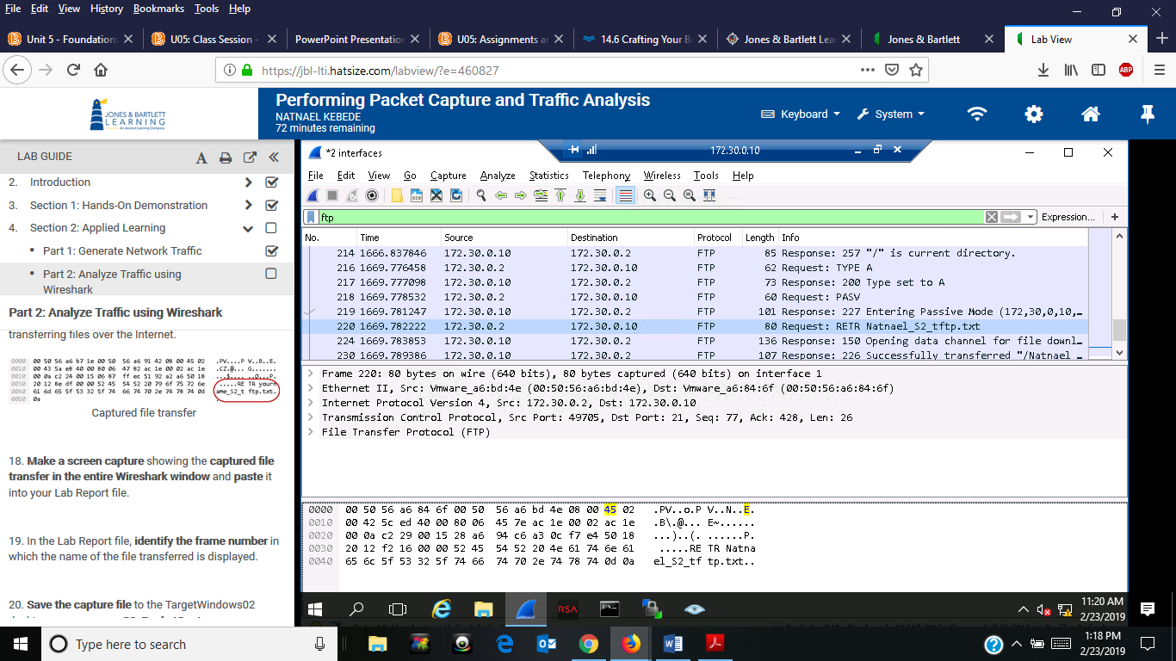

- screen captures showing sesssion detail for the file name natnael_S2_tftp.txt file transfer
